https://github.com/jakevdp/data-USstates/

import pandas as pd
df = pd.DataFrame(
...: {
...: "Name": [
...: "Braund, Mr. Owen Harris",
...: "Allen, Mr. William Henry",
...: "Bonnell, Miss. Elizabeth",
...: ],
...: "Age": [22, 35, 58],
...: "Sex": ["male", "male", "female"],
...: }
...: )
...:

df

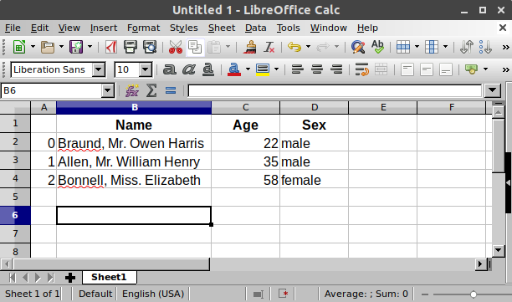
df["Age"]
ages = pd.Series([22, 35, 58], name="Age")

df["Age"].max()
ages.max()
df.describe()

*******************************************************

Titanic Dataset

titanic = pd.read_csv("data/titanic.csv")

titanic.to_excel("titanic.xlsx", sheet_name="passengers", index=False)

titanic = pd.read_excel("titanic.xlsx", sheet_name="passengers")

titanic.dtypes

titanic.info()

titanic.head()

titanic["Name"].str.lower()

titanic["Name"].str.split(",")

titanic["Surname"] = titanic["Name"].str.split(",").str.get(0)

titanic["Surname"]

titanic["Name"].str.contains("Countess")

titanic[titanic["Name"].str.contains("Countess")]

titanic["Name"].str.len()

titanic["Name"].str.len().idxmax()

ages = titanic["Age"]

ages.head()

above_35 = titanic[titanic["Age"] > 35]

above_35.shape
class_23 = titanic[(titanic["Pclass"] == 2) | (titanic["Pclass"] == 3)]

class_23.head()

adult_names = titanic.loc[titanic["Age"] > 35, "Name"]

adult_names.head()

titanic.iloc[9:25, 2:5]

****************************************************************
How to calculate summary statistics
titanic["Age"].mean()
titanic[["Age", "Fare"]].median()
titanic[["Age", "Fare"]].describe()

titanic.agg(
{
"Age": ["min", "max", "median", "skew"],
"Fare": ["min", "max", "median", "mean"],
}
)

titanic[["Sex", "Age"]].groupby("Sex").mean()
titanic.groupby("Sex").mean(numeric_only=True)
titanic.groupby("Sex")["Age"].mean()
titanic.groupby(["Sex", "Pclass"])["Fare"].mean()

No. of records by category

titanic["Pclass"].value_counts()

titanic.groupby("Pclass")["Pclass"].count()

Reshaping layout of tabes
titanic.sort_values(by="Age").head()
titanic.sort_values(by=['Pclass', 'Age'], ascending=False).head()

***************************************************************
no2 = air_quality[air_quality["parameter"] == "no2"]
no2_subset = no2.sort_index().groupby(["location"]).head(2)
no2_subset
no2_subset.pivot(columns="location", values="value")
no2.head()
no2.pivot(columns="location", values="value").plot()

*************************************************************
air_quality = pd.read_csv("data/air_quality_no2.csv", index_col=0, parse_dates=True)

air_quality.head()

air_quality.plot()

air_quality["station_paris"].plot()

air_quality.plot.scatter(x="station_london", y="station_paris", alpha=0.5)

plt.show()

air_quality.plot.box()

axs = air_quality.plot.area(figsize=(12, 4), subplots=True)

plt.show()
fig, axs = plt.subplots(figsize=(12, 4))
air_quality.plot.area(ax=axs)

axs.set_ylabel("NO$_2$ concentration")
fig.savefig("no2_concentrations.png")
plt.show()

fig, axs = plt.subplots(figsize=(12, 4)) # Create an empty Matplotlib Figure and Axes
air_quality.plot.area(ax=axs) # Use pandas to put the area plot on the prepared Figure/Axes
axs.set_ylabel("NO$_2$ concentration") # Do any Matplotlib customization you like
fig.savefig("no2_concentrations.png") # Save the Figure/Axes using the existing Matplotlib method.
plt.show() # Display the plot

*****************************************************************

air_quality = pd.read_csv("data/air_quality_no2.csv", index_col=0, parse_dates=True)
air_quality.head()

air_quality["london_mg_per_cubic"] = air_quality["station_london"] * 1.882
air_quality.head()
air_quality["ratio_paris_antwerp"] = (air_quality["station_paris"] / air_quality["station_antwerp"]
)
air_quality.head()
air_quality_renamed = air_quality.rename(
...: columns={
...: "station_antwerp": "BETR801",
...: "station_paris": "FR04014",
...: "station_london": "London Westminster",
...: }
...: )

air_quality_renamed = air_quality_renamed.rename(columns=str.lower)

